**Question: Do AgNPs have an effect on yellow perch N, P and C excretion?**

**Answer: AgNPs increase N excretion, decrease DOC excretion, and have no effect on P excretion**

**Anova: Log TDN excretion ~ Lake**

summary(aov.N)

Df Sum Sq Mean Sq F value Pr(>F)

Lake 1 7.921 7.921 10.27 0.0032 **

Residuals 30 23.135 0.771

---

Signif. codes: 0 ‘***’ 0.001 ‘**’ 0.01 ‘*’ 0.05 ‘.’ 0.1 ‘ ’ 1

68 observations deleted due to missingness

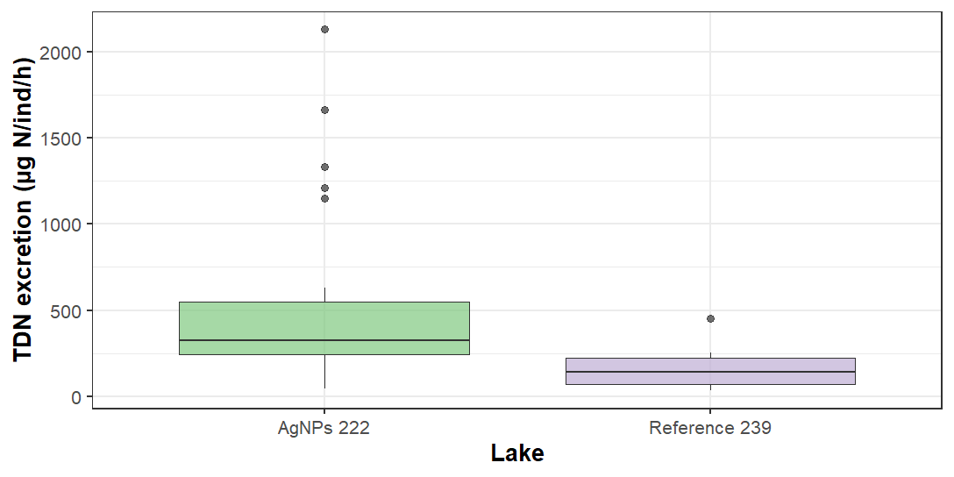

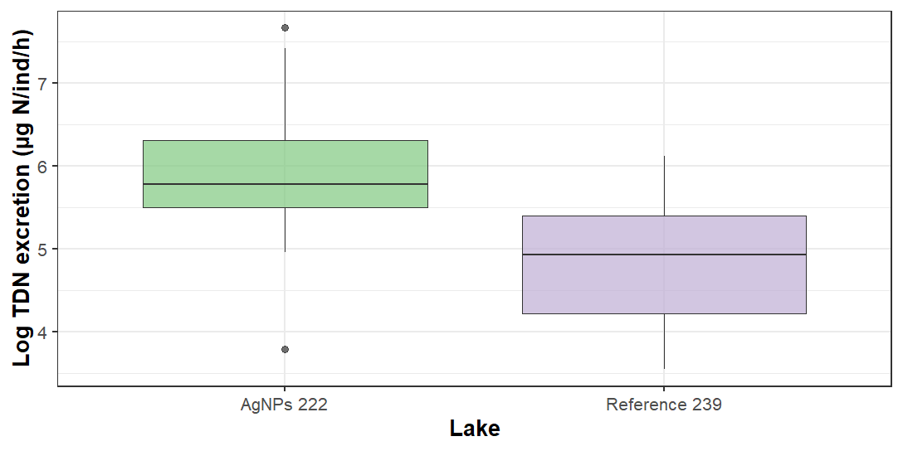

**Anova: TDP excretion ~ Lake**

summary(aov.Pnx)

Df Sum Sq Mean Sq F value Pr(>F)

Lake 1 0.5 0.501 0.019 0.892

Residuals 76 2048.0 26.948

22 observations deleted due to missingness

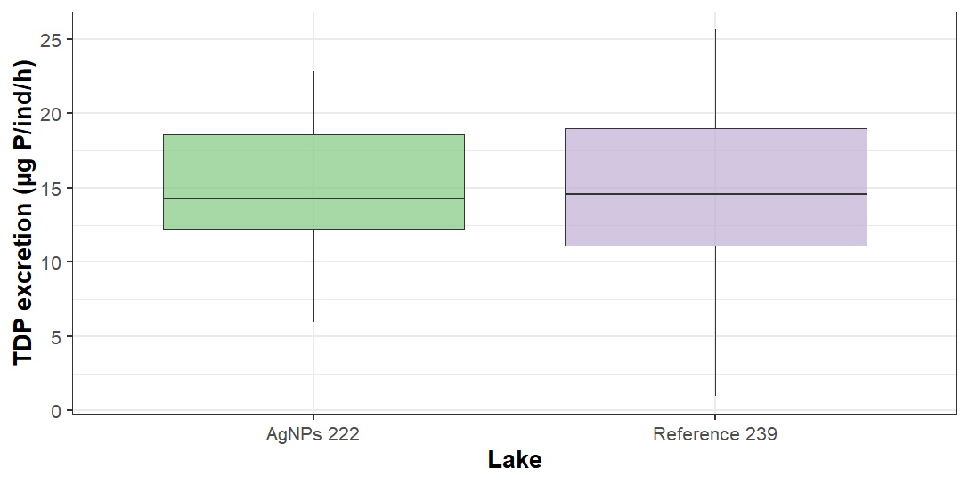

**Anova: TDP excretion ~ Lake*Year**

summary(aov.Px)

Df Sum Sq Mean Sq F value Pr(>F)

Lake 1 0.5 0.501 0.018 0.893

Year 1 2.8 2.825 0.103 0.750

Lake:Year 1 7.2 7.163 0.260 0.612

Residuals 74 2038.0 27.541

22 observations deleted due to missingness

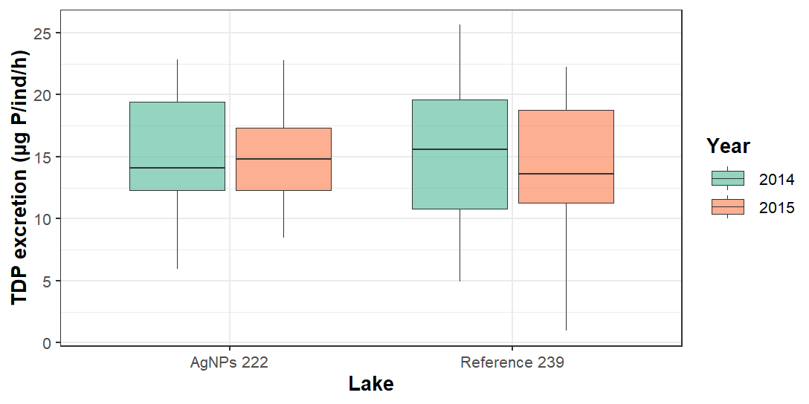

**Anova: DOC excretion ~ Lake**

summary(aov.C)

Df Sum Sq Mean Sq F value Pr(>F)

Lake 1 0.2811 0.28111 4.41 0.0493 *

Residuals 19 1.2112 0.06375

---

Signif. codes: 0 ‘***’ 0.001 ‘**’ 0.01 ‘*’ 0.05 ‘.’ 0.1 ‘ ’ 1

79 observations deleted due to missingness

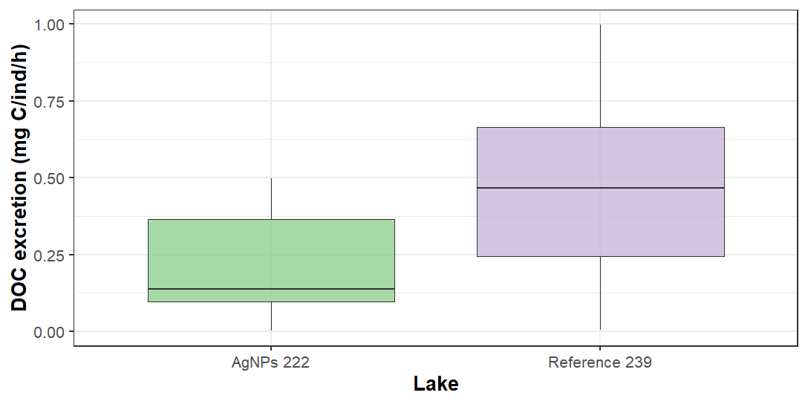

*Note: very low DOC excretion for both lakes*

**Excreted N:P ~ Lake**

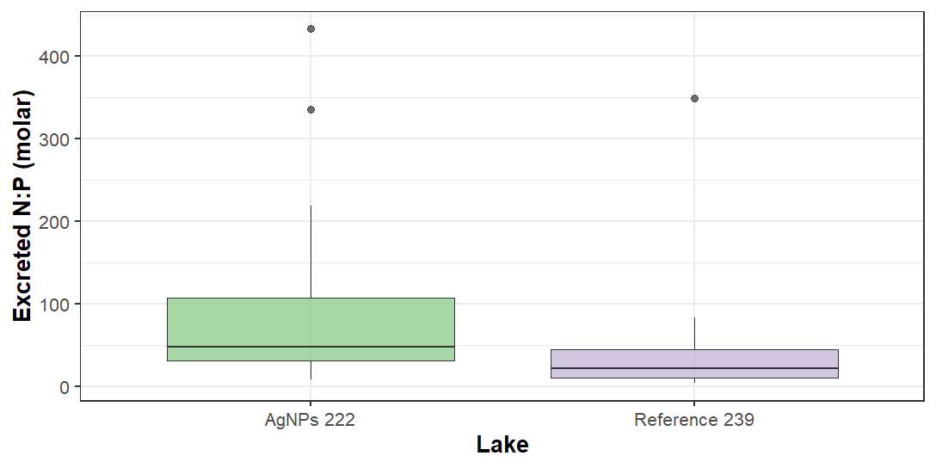

**Excreted C:N ~ Lake**

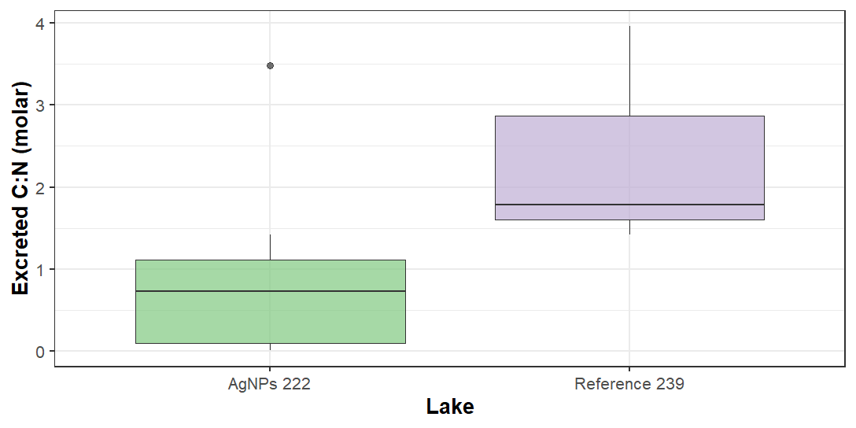

*Note: very low DOC excretion for both lakes*

**Anova: Log Tag excretion ~ Year**

summary(aov.Tag)

Df Sum Sq Mean Sq F value Pr(>F)

Year 1 5.48 5.480 13.5 0.00077 ***

Residuals 36 14.61 0.406

---

Signif. codes: 0 ‘***’ 0.001 ‘**’ 0.01 ‘*’ 0.05 ‘.’ 0.1 ‘ ’ 1

62 observations deleted due to missingness

